Shane Zandotti
Professor Mangini
English Comp. 100
15 April 2018
MLA Research Paper Draft II
Drugs. They are everywhere, in our neighborhoods, streets and increasingly in our culture. Often, people look to them for recreational purposes- to dull pain, be it emotional or physical. This often comes a great price. Increasingly, more and more inmates being incarcerated are being booked for nonviolent crimes that involve drugs. This needs to change.
On average in the US “…only 8 percent of federal prisoners were sentenced for violent crimes in 2011, almost half of federal inmates — 48 percent — were in prison for drug crimes, according to Department of Justice statistics.”(Flatow) This is an astonishingly high number for a crime that is oftentimes at the expense of the individual rather than the community. In a country where overcrowding and recidivism rates are skyrocketing a solution would be to decriminalize drugs. The term decriminalization is a legally defined as removing legislation that defines possession as a felonious offence, punishable by jail time. Decriminalization does NOT make the sale, consumption, and distribution of drugs legal, rather would make penalties much less than before, such as a fine or community service.
The counter argument is clear. What about those users who rob stores, sell to children, and other criminal activity? Well, under the tenets of decriminalization these crimes would still distinguished as egregious, and grounds for jail time. It is important to note how decriminalization would not allow groups to deal drugs, growth or distribution of illicit substances, or even consumption, but would rather make lessen penalties. Those caught dealing to children, committing violent offences while intoxicated, and other violent felonies should still be subjected to trial. Decriminalization would serve to lessen the number of inmates in prison for drug related offenses, freeing up valuable tax dollars.
Often-times when someone is put to trial for a drug offence they are not treated fairly as our justice system puts steep and sometimes unfair penalties on users. As the esteemed Mr. Outlaw states: “…one issue lost in the reform discussion is how throughout federal sentencing law and practice, drug offenses are pervasively linked to violent offenses to lengthen prison sentences. Throughout federal criminal statutes, sentencing guidelines and policies, drug crimes and violent crimes are not only treated equally, but also interchangeably to increase a defendant’s prison sentence.” Clearly the current system needs to be changed. Felony charges should only be applied to those offenses which actively harm others. In law we see many being jailed for crimes that objectively would not be violent, or even the extension of sentencing for drug usage.
By dropping the penalties for consuming drugs this will reduce, if not eliminate much of the stigma surrounding the usage of illicit substances. We see examples of this in Portugal according to Time magazine on the subject of Portugal, “decriminalized the possession of all drugs for personal use in 2001. Since then, overall drug use has fallen, HIV cases among drug users dropped, and overdose deaths are the second lowest in the E.U.” (Bajekal) The truth is, it is working in other nations with easier drug policies than the US. If we look at the numbers, the overall usage of drugs such as cannabis has decreased in countries that either legalized or decriminalized its use. The following is a diagram from the economist which highlights this.

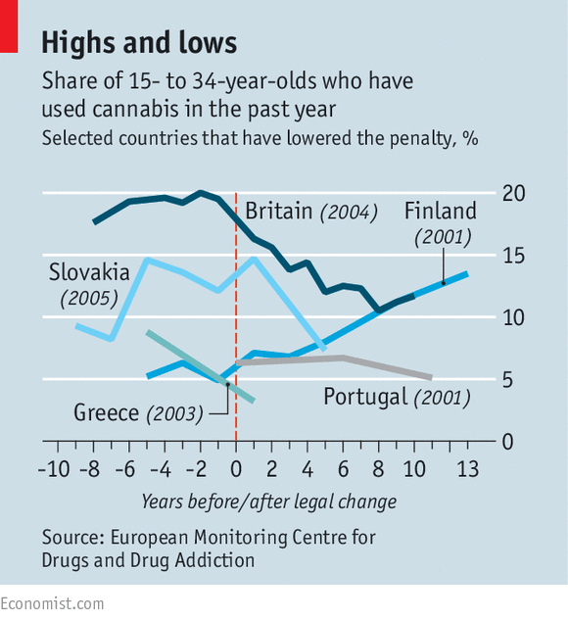

Deaths are on the rise from drug related overdoses and abuse. These numbers continue to rise every year with seemingly no end in sight. Anika Reed, a writer at CQ researcher states that “According to the most recent official statistics, opioids — which include heroin and prescription painkillers such as oxycodone, morphine and methadone — were involved in more than 33,000 deaths in the United States in 2015. Heroin-related deaths alone surpassed gun homicides that year for the first time in recent history.” With these numbers continuing to rise it only becomes clearer that our current precedents are not working, and that legislative action is required for harm reduction. No longer should opioid users be treated as lepers but rather as human beings in need of a helping hand. With the addition of decriminalization, we may see a decline in consumption of psychoactive substances based on the data extrapolated from various studies.
In Portugal studies have shown that opioid related deaths, and HIV rates due to sharing needles have decreased. This is no accident, it is a direct result of their lenient policy and treatment of addicts within their borders. The US needs to follow suit as soon as possible. People are dying simply because they don’t wish to face legal repercussions for actions that are largely out of their control. Researchers J.S. Melo and associates found that “…the impact of law enforcement suggests that police interactions with [people who inject drugs] may increase behavioral risks for injection-driven disease transmission and thereby intensify syndemics.” Melo and colleges came to this conclusion by performing a cross sectional study in three cities, San Fransico, Tijuana, and Vancouver over the course of two years. Their data suggests a strong correlation between previous law enforcement encounters and continued use of intravenous drugs. The implications here a staggering, often societal norms would advocate for increased police presence in order to reduce harm, but this research appears to directly contradict this common theory.

Annotated Bib Decriminalization of Drugs
Outlaw III, Lucius T. "Time for a Divorce: Uncoupling Drug Offenses from Violent Offenses in Federal Sentencing Law, Policy, and Practice." American Journal of Criminal Law, vol. 44, no. 1, Fall2016, pp. 49-69. EBSCOhost, search.ebscohost.com.libdb.dccc.edu/login.aspx?direct=true&db=aph&AN=123263178&site=ehost-live.

Melo, J.S., et al. "Do Law Enforcement Interactions Reduce the Initiation of Injection Drug Use? An Investigation in Three North American Settings." Drug & Alcohol Dependence, vol. 182, Jan. 2018, pp. 67-73. EBSCOhost, doi:10.1016/j.drugalcdep.2017.10.009.

Reed, Anika. "Drug Abuse." CQ Researcher, 29 June 2017, library.cqpress.com/cqresearcher/cqr_ht_drug_abuse_2017.

Drug Offenders in American Prisons: The Critical Distinction Between Stock and Flow
Jonathan Rothwell - https://www.brookings.edu/blog/social-mobility-memos/2015/11/25/drug-offenders-in-american-prisons-the-critical-distinction-between-stock-and-flow/
Moore, Michael, director. Where to Invade Next . Dog Eat Dog Films , 2016

Flatow , Nicole. “Almost Half of Federal Prisoners Held For Drug Crimes.” ThinkProgress, 2 Jan. 2013, thinkprogress.org/almost-half-of-federal-prisoners-held-for-drug-crimes-17db035cc719/.

Bajekal, Naina. "What Happens When Drugs Aren't Illegal?." Time, vol. 186, no. 18, 02 Nov. 2015, p. 10. EBSCOhost, search.ebscohost.com.libdb.dccc.edu/login.aspx?direct=true&db=aph&AN=110516860&site=ehost-live.

"Not Mind-Stretching Enough." Economist, vol. 419, no. 8994, 18 June 2016, p. 55. https://www.economist.com/news/europe/21700648-liberal-drug-policies-have-spread-across-europe-some-early-adopters-are-slipping-behind-not

